**IFT 533: Data Visualization and Reporting for IT**

**Prof Dr. Asmaa**

**Project - Phase I: Planning**

**26th November 2023**

**Team 7:**

**Saketh Velidimalla**

**Venkata Preetham Paritala**

**Geeth Sourabh Petla**

**Sharan Kumar Mogilli**

**Section 1: The Dashboard**

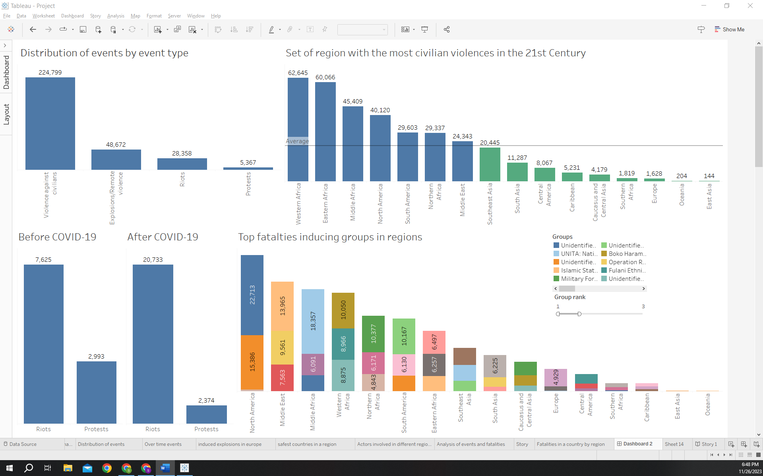

**Brief Explanation:** The dashboard serves as a comprehensive tool for visualizing and analyzing the "Anti-Civilian Violence" dataset from the Armed Conflict Location & Event Data Project (ACLED). It provides interactive and informative visualizations to aid users in understanding global political violence patterns, actor involvement, and the impact on civilian populations.

**Section 2: The Dataset**

**Explanation:** The dataset, sourced from ACLED, captures real-time information on political violence and protest events globally. Key attributes include Event Date, Year, Event Type, Fatalities, Region, Country, Latitude, Longitude, Source, Sub_Event_Type, Disorder_Type, Actors, Iso, Civilian_Targeting, Tags, and Notes. No pre-processing was required for the chosen dataset.

**Section 3: Dashboard Users**

The dashboard caters to diverse users, including:

1. **Journalists:**
   * *Use Case:* Journalists can utilize the dashboard to identify common event types, actors, and locations, aiding in the creation of informed and context-rich news articles. The visualizations provide a quick overview of global political violence patterns.
2. **Tourists:**
   * *Use Case:* Tourists can assess recent protests or riots, understand local political climates, and take travel precautions. The dashboard helps in making informed decisions about travel destinations, considering safety and potential risks.
3. **Lawmakers:**
   * *Use Case:* Lawmakers can use the dashboard to develop policies and strategies addressing underlying causes of violence. The insights derived from the visualizations can inform legislative efforts aimed at promoting peace and stability.
4. **Military:**
   * *Use Case:* Military personnel can gain insights into potential conflict hotspots, understand involved actors, and aid in strategic planning. The dashboard assists in analyzing patterns of political violence, supporting military intelligence and operational planning.
5. **Humanitarian Organizations:**
   * *Use Case:* Humanitarian organizations can leverage the dashboard to identify regions with high levels of violence and plan intervention strategies. They can analyze the types of events, actors involved, and geographical patterns to allocate resources effectively.
6. **Analysts and Researchers:**
   * *Use Case:* Analysts and researchers studying political violence and conflict dynamics can utilize the dashboard to explore trends over time, assess correlations between variables, and conduct in-depth analyses for academic or policy-oriented research.
7. **International Organizations:**
   * *Use Case:* Organizations such as the United Nations or regional bodies can use the dashboard to monitor global political violence trends. This information can aid in diplomatic efforts, peacekeeping missions, and the development of international policies to address conflict and violence.
8. **Security Agencies:**
   * *Use Case:* Security agencies, both at national and international levels, can gain valuable insights into potential hotspots, actor profiles, and the evolution of conflict events. This information can inform security strategies, risk assessments, and intelligence operations.
9. **Risk Management Firms:**
   * *Use Case:* Firms specializing in risk management can utilize the dashboard to assess the political stability of regions for business operations. Understanding the frequency and nature of events, as well as actor involvement, can contribute to informed decision-making in investments and operations.
10. **Academic Institutions (Teaching):**
    * *Use Case:* Academic institutions teaching courses on political science, conflict studies, or international relations can incorporate the dashboard into their curriculum. It provides students with a practical and real-world application for understanding the complexities of political violence.
11. **Non-Governmental Organizations (NGOs):**
    * *Use Case:* NGOs focused on human rights, peacebuilding, or conflict resolution can use the dashboard to monitor and advocate against political violence. The insights can aid in designing programs and interventions aimed at mitigating the impact of violence on affected populations.
12. **Diplomats and Foreign Affairs Officials:**
    * *Use Case:* Diplomats and officials in foreign affairs can utilize the dashboard to stay informed about global political dynamics. This information is crucial for diplomatic relations, crisis management, and developing diplomatic strategies to address conflicts in various regions.
13. **Historians and Archivists:**
    * *Use Case:* Historians studying contemporary history can use the dashboard as a resource to understand and document political violence trends. It serves as a living archive, providing valuable data for historical analysis and documentation.
14. **Emergency Response Teams:**
    * *Use Case:* Emergency response teams can benefit from the dashboard in planning and responding to crises. Understanding the nature and location of events helps in preparing for potential humanitarian emergencies and delivering aid more effectively.
15. **Political Risk Consultants:**
    * *Use Case:* Consultants specializing in political risk analysis can employ the dashboard to enhance their assessments. The information on event types, actors, and geographical patterns contributes to a comprehensive understanding of political risk in different regions.
16. **Educational Researchers:**
    * *Use Case:* Researchers in the field of education can utilize the dashboard to study the impact of political violence on educational systems. This includes analyzing disruptions caused by events and understanding how they affect access to education in conflict-affected areas.

**Section 4: Questions**

1. What are the locations of events that have happened in a particular region.
2. Which are the safest countries to travel to in Southeast Asia?
3. Which set of regions have the most civilian violences in the 21st Century.
4. What is the trend of occurences of protests and riots before and after COVID-19 across the globe.
5. What are the events and fatalities caused by different militant organizations in various countries.
6. Which are the militant groups which induce the most fatalities in regions?
7. What is your analysis of the events and the fatalities that took place in a various region.
8. How has the number of conflict events changed over time?
9. What is the distribution of events by event type?
10. What is the frequency of militant group-induced explosions in Europe?

**Section 5: Plots**

1. **What are the locations of events that have happened in a particular region**?

The geographic occurrences within a specific region are visually represented through a symbol map, wherein distinct colours delineate various event types, and the magnitude of each event is depicted by the size of corresponding circles. Notably, this graphical representation conveys information regarding the geographical distribution and severity of events, with fatalities quantified through circle dimensions.

1. **Which are the safest countries to travel to in Southeast Asia?**

In the context of travel safety in Southeast Asia, the presentation employs a choropleth map to visualize data on fatalities. This map utilizes a graduated colour scheme, with darker shades of red indicating higher numbers of fatalities and conversely, lighter shades representing lower occurrences.

1. **Which set of regions have the most civilian violences in the 21st Century?**

The 21st century's most prone regions to civilian violence are identified through a bar graph. The x-axis signifies regions, with the y-axis depicting fatalities. An average line provides context—regions below it is in green, and those above, in blue. This concise visual aids in assessing and comparing levels of civilian violence across regions.

1. **What is the trend of occurences of protests and riots before and after COVID-19 across the globe?**

The graphical representation illustrating the frequency of protests and riots before and after the onset of the COVID-19 pandemic on a global scale is depicted through a bar graph. In this visualization, the x-axis delineates various regions with distinct occurrences of protests and riots, while the y-axis quantifies the corresponding number of fatalities associated with each instance.

1. **What are the events and fatalities caused by different militant organizations in various countries?**

The depicted visualization is a concise stacked bar graph, with the x-axis denoting militant organizations and the y-axis representing fatality counts across different countries. Each stacked bar highlights various event categories through distinct colours, offering a succinct overview of the diverse incidents and associated fatalities caused by different militant entities on a country-specific basis.

1. **Which are the militant groups which induce the most fatalities in regions?**

The visual representation is a stacked bar graph illustrating fatalities in different regions. The x-axis denotes region types, the y-axis shows fatality numbers, and each bar is segmented by colour to represent various actor types. The design prioritizes a clear ranking of actors based on their contribution to fatalities.

1. **What is your analysis of the events and the fatalities that took place in a various region?**

The chart depicts events and fatalities in a diverse region from 1996 to November 2023. The upper line graph shows event frequency, while the lower one illustrates fatalities. This concise visualization offers insights into the temporal patterns and severity of incidents in the region.

An examination of the events and associated fatalities in diverse regions reveals a conspicuous upswing, particularly within the temporal span from 2015 to 2023. This discernible trend is graphically represented in a bar chart, wherein each bar corresponds to the magnitude of fatalities within distinct regions.

In our analysis, we direct attention to the distinct regions affected during a significant period marked by heightened events, with a specific emphasis on the Middle East. Our presentation incorporates a visual representation in the form of a stacked bar graph, wherein the x-axis delineates individual countries within the Middle East, and the y-axis quantifies the corresponding fatality figures. Each segment of the stacked bars is assigned a unique color to signify various sub-event types, contributing to a comprehensive depiction of the occurrences and their associated impact on the region.

1. **How has the number of conflict events changed over time?**

The graphical representation illustrates temporal shifts in the frequency of conflict events through a line graph, wherein the horizontal axis delineates the chronological progression by year, and the vertical axis quantifies the number of occurrences. Each distinct category of event is visually distinguished by employing varied colors for individual lines, thereby facilitating a comprehensive understanding of the nuanced dynamics inherent in the dataset.

1. **What is the distribution of events by event type?**

The distribution of events by event type is visually represented through a bar graph. In this graphical representation, the x-axis denotes the various event types, while the y-axis quantifies the number of events attributed to each type.

1. **What is the frequency of militant group-induced explosions in Europe?**

The frequency of explosions induced by militant groups in Europe is depicted through a choropleth map. This visual representation employs a sequential colour scheme, with darker shades of blue indicating a higher number of explosions and lighter shades corresponding to lower frequencies.

**Section 6: Interactivity**

**Controls:**

1. **Dropdown Menus:** Implemented in various sheets, allowing users to select specific countries, regions, or event types for a more focused analysis.
2. **Range Selection:** Utilized in sheets involving temporal data, enabling users to filter events based on specific years or date ranges.
3. **Colour Intensity Filters:** Applied in choropleth maps to represent variations, offering an interactive exploration of explosion quantities and intensity.
4. **Legend Controls:** In charts with legends, users can interactively explore specific event types by toggling them on or off for a clearer visualization.

**Functionality:**

1. **Dynamic Filtering:** Dropdown menus provide users with the flexibility to dynamically filter data based on their preferences, enhancing the specificity of the analysis.
2. **Temporal Exploration:** Range selection controls allow users to focus on a particular time frame, facilitating a detailed examination of trends before and after significant events such as COVID-19.
3. **Geospatial Insight:** Colour intensity filters on choropleth maps offer an interactive experience in exploring the frequency of militant group-induced explosions in Europe, with variations in colour representing different levels of intensity.
4. **Event Type Selection:** Legends in certain charts enable users to interactively explore specific event types, contributing to a more nuanced understanding of the dataset.

The incorporation of these interactive elements empowers users to customize their analysis, providing a user-friendly and exploratory experience within the dashboard.

**Section 7: References**

* Dataset Link: [Armed Conflict Location & Event Data Project (ACLED)](https://acleddata.com/)
* Mural link: : [Team Mural](https://app.mural.co/t/ift533dv7772/m/ift533dv7772/1699476534844/50dd7e2dc7d0ed3e735ecd922c6964c71cee347a?sender=u3335f695051373ad535c3764)
* **Dashboard link:**

<https://public.tableau.com/app/profile/geeth.petla/viz/shared/X4P5GN5RQ>

Top of Form